
HURA TAPAIRU
MEHURA MANIHINI

- Required documents -

Each group registered for Hura Tapairu Manihini must provide the following digital elements to Te Fare Tauhiti Nui - Maison de la Culture in order to facilitate the successful execution of the event. It is therefore important to follow the established deadlines.

The team at Te Fare Tauhiti Nui - Maison de la Culture can provide assistance with translations in French, English, and Spanish if needed.

All documents are to be returned to Te Fare Tauhiti Nui - Maison de la Culture in digital format so that our teams can make any necessary modifications if needed.

The documents to be returned by 1 month before the event, are as follows:

- Presentation file:
- The presentation file will be useful for the press conference.
- A brief presentation of the dance group, including any awards;
- A dance group presentation text between 100 and 220 words maximum, in reo mā'ohi translated into French and/or English and Spanish, to be used by the presenter during the evening;
- The title and summary of the theme of between 100 and 220 words maximum in reo mā’ohi with their translations into French and/or English and Spanish.

- Competition file:
- The competition file is forwarded to the jury.
- The competition categories in which the formation is registered;
- The full text of the theme between 1 and 5 pages, in reo mā'ohi as well as in English and/or French (if the English or French version is missing, TFTN can take care of the translation);
- The lyrics of all songs in reo mā'ohi with the names of the authors-composers and their translation into English and/or French;
- The texts of all ‘ōrero in reo mā’ohi, along with their translations into English and/or French, and the names of the authors.

- Technical file:
- The technical file is forwarded to the teams.
- The detailed technical sheets for sound and lighting;
- The detailed program (rehearsal schedule) of the performance;
- The nominal list of formation performers participating in the competition (last name, first name, gender, date and place of birth) and their role (musician, dancer, etc.), along with a photocopy of identification for each member;
- The list of songs with the names of the authors-composers (SACEM).
- The permissions to exploit image rights (minors and adults).
PRESENTATION FILE

- The presentation file will be useful for the press conference.
  - A brief presentation of the formation, including any awards;
  - A formation presentation text between 100 and 220 words maximum, in reo mā'ohi translated into French and/or English and Spanish, to be used by the presenter during the evening;
  - The title and summary of the theme of between 100 and 220 words maximum in reo mā’ohi with their translations into French and/or English and Spanish.

BRIEF PRESENTATION OF THE GROUP

DANCE GROUP:

Name of the group:
Group creation date:
Country:
Awards of the group:

GROUP LEADER:
Name:
First name(s):
Phone number:
Email:

GROUP COMPOSITIONS:

Group leader:

Bandleader:

Choreographer:

Author of the theme:

Songwriters:

Composers:

Videographer:

Photographer:

Stage manager:

DANCE GROUP PRESENTATION TEXT

A group presentation text of between 100 and 220 words maximum, translated into French and/or English and Spanish, to be used by the presenter during the evening.

These details will be used for introducing the group during your performance.

Reo mā’ohi
Presentation text :

In french
Presentation text :

In english or spanish
Presentation text :

THEME SUMMARY

The title and summary of the theme of between 100 and 220 words maximum in reo mā’ohi with their translations into French and/or English and Spanish.

Reo mā’ohi
Presentation text :

In french
Presentation text :

In english or spanish
Presentation text :

COMPETITION FILE
- The competition file is forwarded to the members of the jury.
  - The competition categories in which the formation is registered;
  - The full text of the theme between 1 and 5 pages, in reo mā'ohi as well as in English and/or French and/or Spanish (if the English or French or Spanish version is missing, TFTN can take care of the translation);
  - The lyrics of all songs in reo mā'ohi with the names of the authors-composers and their translation into English and/or French and/or Spanish;
  - The texts of all ‘ōrero in reo mā’ohi, along with their translations into English and/or French and/or Spanish, and the names of the authors.

Check the competition categories in which the formation is registered:
Competition category
☐ MEHURA MANIHINI
☐ TAPAIRU MANIHINI (‘ōte’a and ‘aparima )
☐ MEHURA MANIHINI & TAPAIRU MAINIHINI

FULL TEXT OF THE THEME

Reo mā’ohi
Title of the theme :
Author :
Translator :
Full text:

In french
Title of the theme :
Author :
Translator :
Full text:

In english or spanish
Title of the theme :
Author :
Translator :
Full text:

LYRICS OF THE SONGS

Reo mā’ohi
Title of the theme :
Author :
Composer :
Lyrics :

In french
Title of the theme :
Author :
Composer:
Translator :
Lyrics:

In english or spanish
Title of the theme :
Author :
Composer:
Translator :
Lyrics:

TEXTS OF ALL THE ‘ŌRERO

Reo mā’ohi
Title of the theme :
Author :
Translator :
Full text:

In french
Title of the theme :
Author :
Translator :
Full text:

In english or spanish
Title of the theme :
Author :
Translator :
Full text:

TECHNICAL FILE
- The technical file is forwarded to the teams.
  - The detailed technical sheets for sound and lighting;
  - The detailed program (rehearsal schedule) of the performance;
  - The nominal list of group performers participating in the competition (last name, first name, gender, date and place of birth) and their role (musician, dancer, etc.), along with a photocopy of identification for each member;
  - The list of songs with the names of the authors-composers (SACEM).
  - The permissions to exploit image rights (minors and adults).

The technical files allow the technicians to prepare and anticipate the needs of each group.

General rehearsal with technicians (sound and lighting):
- Mehura Manihini Category: 30 minutes.
- Hura Tapairu Manihini Category: 1 hour.

THE SOUND AND LIGHTING TECHNICAL SHEET
It is provided to assist in the choice of:
- Lighting effects
- Arrangement of the band
- Gathering information on other possible parameters of the Grand Théâtre
Document to be filled in annex (See Annex 2)

Diagram of the stage at the Grand Théâtre.
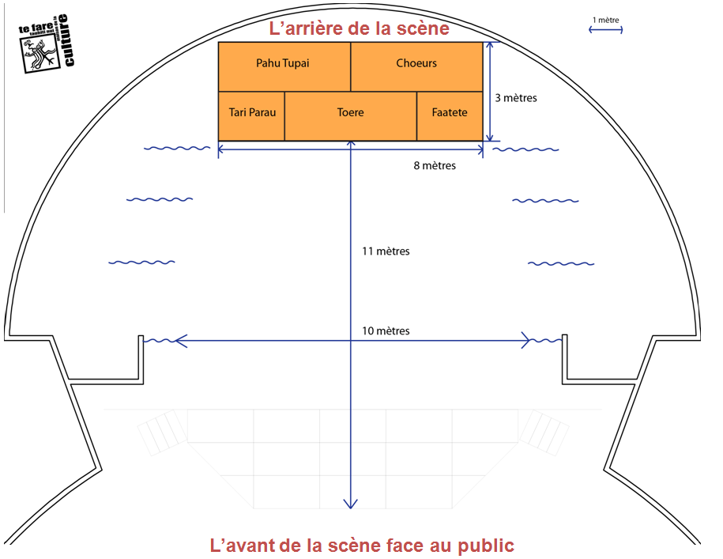

Front of the stage
Note: Musician #1 is the one located at the far left (ocean side), and musician 6 is the one situated at the far right (mountain side) as viewed by the audience.

It is preferable for stringed instruments to be electro-acoustic (they can be wired to a PA system) for better sound quality. Each musician playing an electro-acoustic string instrument will need to supply the jack-jack cable. In addition, as some instruments are battery-powered, batteries must be replaced before each performance. (Before the Sound-check, and before the performance)

The sound console is of digital type, and all settings made during the 'Sound-check' for the formation are saved to be recalled during the performance night of the formation. Hence, it is crucial that what is done during the 'Sound-check' matches the performance night.

- - No instrument changes between the sound-check and the evening of the performance.
- - No change of instrument location.

Please note: for live bands, we strongly advise the band to bring along a stage manager at rehearsals and at the evening of the performance. The stage manager will be stationed with the sound and lighting technicians to anticipate all desired effects.

Name of the dance group:

Coordinator:

Email:

Phone number:

Sound and lighting stage manager:

The detailed sound and lighting technical sheet

 | Musician 1 | Musician 2 | Musician 3 | Musician 4 | Musician 5 | Musician 6
Names of Musicians
Main Instrument
Instrument 2
Instrument 3
Instrument 4
Instrument 5
Vocal
Yes / No

 | Singer 1 | Singer 2 | Singer 3
Name of the singers

THE DETAILED PROGRAM (REHEARSAL SCHEDULE) OF THE PERFORMANCE

It corresponds to the chronological sequence of the performance.

See the example below:
Detailed program –TAPAIRU Manihini Category  ‘ŌTE’A block:  - Entrance: ‘Ōte’a Tomora’a  - ‘Ōte’a ‘Āmui  - ‘Ōte’a Tāne  - ‘Ōte’a Vahine  APARIMA block:  - ‘Aparima ‘Āmui  - ‘Aparima Tāne  - ‘Aparima Vahine  - Exit: Pehe Aroha | Detailed program –MEHURA Manihini Category  Entrance and/or opening  Song 1: title of the song  Song 2: title of the song  Song 3: title of the song  Exit and/or finale

The detailed program (rehearsal schedule) of the performance

Check the competition category in which the formation is registered:
- MEHURA MANIHINI

- TAPAIRU MANIHINI

Name of the dance group: __________________________________________

Act | STAGING | LIGHTING | MUSIC
1 | Entrance of the ‘Orero | Spotlight on the ‘Orero | Vivo

List of the performers of the formation (1/2)
*Photocopy of ID required for all formation performers

MUSICIANS (5 minimum to 6 maximum)
 | First name and Surname | Role within the band | Gender | Date of birth | Place of birth
1
2
3
4
5
6

SINGERS (from 0 to 3 maximum)
 | First name | Surname | Gender | Date of birth | Place of birth
1
2
3

‘ŌRERO (1 maximum – optional)
 | First name | Surname | Gender | Date of birth | Place of birth
1

EXTRAS OR ACTORS (from 0 a 5 maximum)
 | First name | Surname | Gender | Date of birth | Place of birth
1
2
3

List of the performers of the formation (2/2)
*Photocopy of ID required for all formation performers

MALE DANCERS/FEMALE DANCERS (8 minimum up to 20 maximum)
 | First name | Surname | Gender | Date of birth | Place of birth
1
2
3
4
5
6
7
8
9
10
11
12
13
14
15
16
17
18
19
20

TE FARE TAUHITI NUI – MAISON DE LA CULTURE
HURA TAPAIRU MANIHINI
– Photo/Media Release authorization form – LEADER GROUP -

Te Fare Tauhiti Nui - Maison de la Culture (TFTN) sets up a system of photographers, cameramen and journalists at each edition of the event: Hura Tapairu.

The group leader registering their training at the event accepts by definition the taking of photos and video recordings of the training by providers accredited by TFTN.

This authorization defines the conditions of use of said images made during the Hura Tapairu 2025.

I, ……………………………………………, leader of the dance group ……………………………. hereby authorize the public institution Te Fare Tauhiti Nui – Maison de la Culture (TFTN) and its partners:
- to permit the execution of the capture and recording of my image (through photography, video, or other audiovisual means) during rehearsals and performances of Hura Tapairu.
- and to use my image in French Polynesia, France, and internationally, across all current and future media and formats (including print publications, radio, television, posters, websites, social networks, mobile applications, and other digital or print platforms), including through paid live streaming on platforms operated or managed by TFTN and its partners. This use is intended to support the representation or reproduction—whether in whole or in part—of the event (i.e., Hura Tapairu), by TFTN or by any authorized third party to whom the rights for exploitation of the show have been granted.

The exploitation of images may be used for:
- educational and training materials;
- public awareness and informational content;
- institutional communication or promotion of TFTN-organized events;
- the celebration and promotion of Polynesian culture;
- commemorative or retrospective content;
- and, more broadly, for any use aligned with TFTN’s public service objectives.

I also give permission for my name and identity to be used in connection with my image.

I confirm that I am not subject to any agreement with a third party that would restrict or prevent the execution of this authorization.

This consent remains valid until December 31, 2027, starting from the conclusion date of Hura Tapairu 2025.

I reserve the right to request information at any time regarding the use of my image, by submitting a written request via email to the following address: communication.tftn@maisondelaculture.pf

Done at ………………………………., on ………………………………….. in 2 original copies.
Signature followed by “read and approved”.

TE FARE TAUHITI NUI – MAISON DE LA CULTURE
HURA TAPAIRU MANIHINI

– Photo/Media Release authorization form - MINORS –

LAST NAME OF THE CHILD: …………………………………………………………………………….
NAME OF THE CHILD: ……………………………………………………………………………………
DATE OF BIRTH: …………………………………………………………………………………………..
NAME OF THE DANCE GROUP: ……………………………………………………………………………
I, THE UNDERSIGNED: (only the father, the mother or the legal representative of the minor)
LAST NAME :
NAME :
PHONE NUMBER :
EMAIL ADRESS :
Hereby authorize Te Fare Tauhiti Nui – Maison de la Culture (TFTN) and its partners:
- to permit the execution of the capture and recording of my image (through photography, video, or other audiovisual means) during rehearsals and performances of Hura Tapairu.
- and to use my image in French Polynesia, France, and internationally, across all current and future media and formats (including print publications, radio, television, posters, websites, social networks, mobile applications, and other digital or print platforms), including through paid live streaming on platforms operated or managed by TFTN and its partners. This use is intended to support the representation or reproduction—whether in whole or in part—of the event (i.e., Hura Tapairu), by TFTN or by any authorized third party to whom the rights for exploitation of the show have been granted.

The exploitation of images may be used for:
- educational and training materials;
- public awareness and informational content;
- institutional communication or promotion of TFTN-organized events;
- the celebration and promotion of Polynesian culture;
- commemorative or retrospective content;
- and, more broadly, for any use aligned with TFTN’s public service objectives.

I also give permission for my name and identity to be used in connection with my image.

I confirm that I am not subject to any agreement with a third party that would restrict or prevent the execution of this authorization.

This consent remains valid until December 31, 2027, starting from the conclusion date of Hura Tapairu 2025.
I reserve the right to request information at any time regarding the use of my image, by submitting a written request via email to the following address: communication.tftn@maisondelaculture.pf
Done at ………………………………., on ………………………………….. in 2 original copies.
Signature followed by “read and approved”.

TE FARE TAUHITI NUI – MAISON DE LA CULTURE
HURA TAPAIRU MANIHINI

– Photo/Media Release authorization form GROUP LEADER –

Te Fare Tauhiti Nui - Maison de la Culture (TFTN) sets up a system of photographers, cameramen and journalists at each edition of the event: Hura Tapairu.

The group leader registering their training at the event accepts by definition the taking of photos and video recordings of the training by providers accredited by TFTN.

This authorization defines the conditions of use of said images made during the Hura Tapairu 2025.

I, ……………………………………………, leader of the dance group ……………………………. hereby authorize the public institution Te Fare Tauhiti Nui – Maison de la Culture (TFTN) and its partners:
- to permit the execution of the capture and recording of my image (through photography, video, or other audiovisual means) during rehearsals and performances of Hura Tapairu.
- and to use my image in French Polynesia, France, and internationally, across all current and future media and formats (including print publications, radio, television, posters, websites, social networks, mobile applications, and other digital or print platforms), including through paid live streaming on platforms operated or managed by TFTN and its partners. This use is intended to support the representation or reproduction—whether in whole or in part—of the event (i.e., Hura Tapairu), by TFTN or by any authorized third party to whom the rights for exploitation of the show have been granted.

The exploitation of images may be used for:
- educational and training materials;
- public awareness and informational content;
- institutional communication or promotion of TFTN-organized events;
- the celebration and promotion of Polynesian culture;
- commemorative or retrospective content;
- and, more broadly, for any use aligned with TFTN’s public service objectives.

I also give permission for my name and identity to be used in connection with my image.

I confirm that I am not subject to any agreement with a third party that would restrict or prevent the execution of this authorization.

This consent remains valid until December 31, 2027, starting from the conclusion date of Hura Tapairu 2025.

I reserve the right to request information at any time regarding the use of my image, by submitting a written request via email to the following address: communication.tftn@maisondelaculture.pf

Done at ………………………………., on ………………………………….. in 2 original copies.
Signature followed by “read and approved”.

reo mā'ohi : Polynesian languages
‘ōrero: speech
‘ōrero: speech

