
HURA TAPAIRU
TAPAIRU MANIHINI

- Required documents -

Each group registered for Hura Tapairu Manihini must provide the following digital elements to Te Fare Tauhiti Nui - Maison de la Culture in order to facilitate the successful execution of the event. It is therefore important to adhere to the prescribed deadlines.

The team at Te Fare Tauhiti Nui - Maison de la Culture can provide assistance with translations in French, English, and Spanish if needed.

All documents are to be returned to Te Fare Tauhiti Nui - Maison de la Culture in digital format so that our teams can make any necessary modifications if needed.

The documents to be returned by October 9, 2023, are as follows:

- Presentation file:
- The presentation file will be useful for the press conference.
- A brief presentation of the formation, including any awards;
- A formation presentation text of between 100 and 220 words maximum, translated into French and/or English and Spanish, to be used by the presenter during the evening;
- The title and summary of the theme of ten (10) to twenty (20) lines maximum in reo mā’ohi with their translations into French and/or English and Spanish.

- Competition file:
- The competition file is forwarded to the jury.
- The competition categories in which the formation is registered;
- The full text of the theme in reo mā'ohi* as well as in English and/or French (if the English or French version is missing, TFTN can take care of the translation);
- The lyrics of all songs in reo mā'ohi* with the names of the authors-composers and their translation into English and/or French;
- The texts of all les ‘ōte’a, en reo mā’ohi, with their translation into English and/or French;
- The texts of all ‘ōrero in reo mā’ohi, along with their translations into English and/or French, and the names of the authors.

- Technical file:
- The technical file is forwarded to the teams.
- The detailed program (rehearsal schedule) of the performance;
- The detailed technical sheets for sound and lighting;
- The nominal list of formation performers participating in the competition (last name, first name, gender, date and place of birth) and their role (musician, dancer, etc.), along with a photocopy of identification for each member;
- The list of songs with the names of the authors-composers (SACEM).
-----
* reo mā’ohi is understood in the sense of the Polynesian language of French Polynesia.
-----

PRESENTATION FILE

- The presentation file will be useful for the press conference.
- A brief presentation of the formation, including any awards;
- A formation presentation text of between 100 and 220 words maximum, translated into French and/or English and Spanish, to be used by the presenter during the evening;
- The title and summary of the theme of ten (10) to twenty (20) lines maximum in reo mā’ohi with their translations into French and/or English and Spanish.

* reo mā’ohi is understood in the sense of the Polynesian language of French Polynesia.

Brief presentation of the Formation

DANCE GROUP:

Name of the group:
Group creation date:
Country:
Awards of the group:

PERSON IN CHARGE:
Name:
First name(s):
Phone number:
Email:

GROUP COMPOSITIONS:

Group leader:

Bandleader:

Choreographer:

Author of the theme:

Songwriters:

Composers:

Videographer:

Photographer:

Stage manager:

FORMATION INTRODUCTION TEXT:

A group presentation text of between 100 and 220 words maximum, translated into French and/or English and Spanish, to be used by the presenter during the evening;
These details will be used for introducing the group during your performance.

TITLE OF THE THEME
(In reo mā’ohi and translated into French)

THEME SUMMARY:
(In reo mā’ohi and translated into French)

- Mandatory for formations competing in the TAPAIRU category
- The title and summary of the theme of ten (10) to twenty (20) lines maximum in reo mā’ohi with their translations into French and/or English and Spanish.

Summary in vernacular language (Tahitian or other) | Summary in French and/or English or Spanish

COMPETITION FILE
- The competition file is forwarded to the jury.
- The competition categories in which the group is registered;
- The full text of the theme in reo mā'ohi* as well as in English and/or French (if the English or French version is missing, TFTN can take care of the translation);
- The lyrics of all songs (hīmene) in reo mā'ohi* with the names of the authors-composers and their translation into English and/or French;
- The texts of all ‘ōte’a, in reo mā’ohi*, along with their translations into English and/or French, and the names of the authors.
- The texts of all ‘ōrero in reo mā’ohi*, along with their translations into English and/or French, and the names of the authors.

* reo mā’ohi is understood in the sense of the Polynesian language of French Polynesia.

Check the competition categories in which the formation is registered:
Competition category
☐ MEHURA MANIHINI ☐ TAPAIRU MANIHINI (‘ōte’a and ‘aparima )

☐ MEHURA MANIHINI & TAPAIRU MAINIHINI

FULL TEXT OF THE THEME:
(in reo mā’ohi and translated into French and/or English and Spanish)

- Mandatory for groups competing in the TAPAIRU category

In vernacular language (Tahitian or other)  Vernacular title: | In French or English or Spanish  Title in French or English:
Author of the theme:  Translator:  Full text: | Author of the theme:  Translator:  Full text:

LYRICS OF THE SONGS:
(In reo mā’ohi and translated into French or English)

In vernacular language (Tahitian or other)  Vernacular title: | In French, English or Spanish  Title in French:
Author:  Composer: | Author:  Composer:
Lyrics: | Translated lyrics:

TEXTS OF ALL ‘ŌTE’A :
(In reo mā’ohi and translated into French or English)

In vernacular language (Tahitian or other)  Vernacular title: | In French, English or Spanish  Title in French:
Author:  Composer: | Author:  Composer:
Lyrics: | Translated lyrics:
TEXTS OF ALL THE ‘ŌRERO:
(In reo mā’ohi and translated into French or English)

In vernacular language (Tahitian or other)  Vernacular title: | In French, English or Spanish  Title in French:
Author:  Composer: | Author:  Composer:
Lyrics: | Translated lyrics:
TECHNICAL FILE

- The technical file is forwarded to the teams.
- The detailed program (rehearsal schedule) of the performance;
- The detailed technical sheets for sound and lighting;
- The nominal list of formation performers participating in the competition (last name, first name, gender, date and place of birth) and their role (musician, dancer, etc.), along with a photocopy of identification for each member;
- The list of songs with the names of the authors-composers (SACEM).

The technical dossier allows the technicians to prepare and anticipate the needs of each one.
General rehearsal with technicians (sound and lighting):

- Mehura Manihini Category: 30 minutes.
- Hura Tapairu Manihini Category: 1 hour.

THE DETAILED PROGRAM (REHEARSAL SCHEDULE) OF THE PERFORMANCE

It corresponds to the chronological sequence of the performance.

See the example below:
Detailed program –TAPAIRU Manihini Category  ‘ŌTE’A block:  - Entrance: ‘Ōte’a Tomora’a  - ‘Ōte’a Amui  - ‘Ōte’a Tāne  - ‘Ōte’a Vahine  ‘Öte’a ‘äpipiti  Aparima ‘äpipiti  APARIMA block:  - ‘Aparima Amui  - ‘Aparima Tāne  - ‘Aparima Vahine  - Exit: Pehe Aroha | Detailed program –MEHURA Manihini Category  Entrance and/or opening  Song 1: title of the song  Song 2: title of the song  Song 3: title of the song  Exit and/or finale

The detailed program (rehearsal schedule) of the performance

Check the competition category in which the formation is registered:
- MEHURA MANIHINI

- TAPAIRU MANIHINI

Name of the formation: ____________________________________________

Act | STAGING | LIGHTING | MUSIC
1 | Entrance of the ‘Orero | Spotlight on the ‘Orero | Vivo

THE SOUND AND LIGHTING TECHNICAL SHEET
It is provided to assist in the choice of:
- Lighting effects
- Arrangement of the band
- Gathering information on other possible parameters of the Grand Théâtre
Document to be filled in annex (See Annex 2)

Diagram of the stage at the Grand Théâtre.
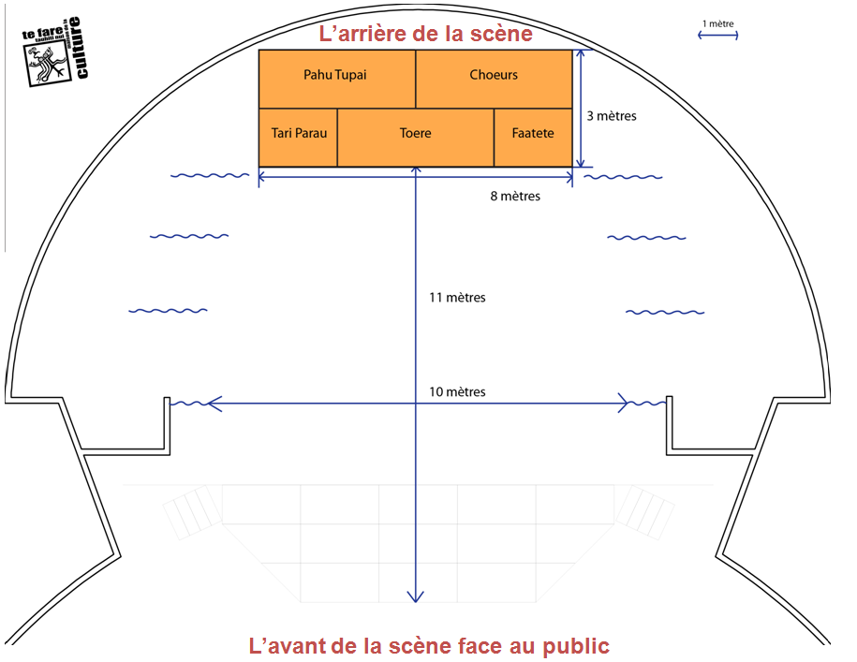

Note: Musician 1 is the one located at the far left (ocean side), and musician 6 is the one situated at the far right (mountain side) as viewed by the audience.

It is preferable for stringed instruments to be electro-acoustic (they can be wired to a PA system) for better sound quality. Each musician playing an electro-acoustic string instrument will need to supply the jack-jack cable. In addition, as some instruments are battery-powered, batteries must be replaced before each performance. (Before the Sound-check, and before the performance)

The sound console is of digital type, and all settings made during the 'Sound-check' for the formation are saved to be recalled during the performance night of the formation. Hence, it is crucial that what is done during the 'Sound-check' matches the performance night.

- - No instrument changes between the sound-check and the evening of the performance.
- - No change of instrument location.

Please note: for live bands, we strongly advise the band to bring along a stage manager for rehearsals and the evening of the performance. The stage manager will be stationed with the sound and lighting technicians to anticipate all desired effects.

The detailed sound and lighting technical sheet

 | Musician 1 | Musician 2 | Musician 3 | Musician 4 | Musician 5 | Musician 6
Names of Musicians
Main Instrument
Instrument 2
Instrument 3
Instrument 4
Instrument 5
Vocal
Yes / No
 | Singer 1 | Singer 2 | Singer 3
Name of the Singers
Name of the formation:

Coordinator:

Email:

Phone number:

Sound and lighting stage manager: ______________________________________________________________

List of the performers of the formation (1/2)
*Photocopy of ID required for all formation performers

MUSICIANS (5 minimum to 6 maximum)
 | First name and Surname | Role within the band | Gender | Date of birth | Place of birth
1
2
3
4
5
6

SINGERS (from 0 to 3 maximum)
 | First name | Surname | Gender | Date of birth | Place of birth
1
2
3

‘ŌRERO (1 maximum – optional)
 | First name | Surname | Gender | Date of birth | Place of birth
1

List of the performers of the formation (2/2)
*Photocopy of ID required for all formation performers

MALE DANCERS/FEMALE DANCERS (13 minimum up to 30 maximum)
 | First name | Surname | Gender | Date of birth | Place of birth
1
2
3
4
5
6
7
8
9
10
11
12
13
14
15
16
17
18
19
20
21
22
23
24
25
26
27
28
29
30


  HURA TAPAIRU MANIHINI
  – Parental consent form for a minor child –

SURNAME OF THE CHILD:
FIRST NAME OF THE CHILD:
DATE OF BIRTH:

I, the undersigned: (Only the FATHER, the MOTHER or the legal representative of the minor child)
SURNAME:
FIRST NAME:
ADDRESS:
VILLE:

PHONE:

Passport no.:
(Photocopy to be ATTACHED REQUIRED)

I authorize my son/daughter, to participate in the Hura Tapairu Manihini under my full responsibility and waive all claims, both for him/her, and for my assigns, against the organizers and other service providers during the said event.

Done at,
on, ...................................................

Parent's signature followed by “read and approved”

reo mā’ohi:Polynesian language
‘ōte’a: danse
‘ōrero: speech
reo mā’ohi:Polynesian language
reo mā’ohi:langue polynésienne
Hīmene: song
‘ōte’a: danse
‘ōrero: speech

