
HURA TAPAIRU MANIHINI

- Documents to be provided -

Each group registered for Hura Tapairu Manihini must provide the Maison de la Culture – Te Fare Tauhiti Nui with the digital items listed below to enable the proper implementation of the event, namely the preparation of press kits, presenter’s sheets and files distributed to all members of the jury. It is therefore important to meet the submission deadlines.

Te Fare Tauhiti Nui – Maison de la Culture can assist in translation into French and English if necessary.

All files must send to Maison de la Culture – Te Fare Tauhiti Nui.
Digitals files is mandatory.

Elements to be provided are the following ones :

- Presentation file : Deadline : October, 9th 2023
- A presentation of the group in French and/or in English
- The title of the theme in reo ma’ohi, translated into French and/or English

- Competition file : Deadline : October, 9th 2023
- The full text of the theme of the show in Reo ma’ohi* and translated into English and/or French
- The lyrics of all songs in Reo ma’ohi* and translated into English and/or French with the names of songwriters/composers
- The list of members participating in the contest and their function into (dancers, musician, etc…) along with photocopy of ID for each member. (Annex 1)

The competition file is sent to jury.

- Technical file : Deadline : Two weeks before the rehearsal
- The detailed programme (run-through) of the show. Annex 2
- The sound and light specifications. Annex 3

-----
* reo mā’ohi means one of the Polynesian language of French Polynesia.
-----

PRESENTATION FILE – deadline : Ocotber, 9th 2023

- A presentation of the group in French and/or in English
- The title of the theme in reo ma’ohi, translated into French and/or English

PRESENTATION OF GROUP

DANCE GROUP :

Name of the groupe : ______________________________________________________________________
Group set up date : _______________________________________________________________________
Country : _______________________________________________________________________________
Awards :

LEADER OF GROUP :
First name : _____________________________________________________________________________
Last name : _____________________________________________________________________________
Phone number : __________________________________________________________________________
Email : ________________________________________________________________________________

MEMBERS OF GROUP :

Choregrapher : __________________________________________________________________________

Author of theme : ________________________________________________________________________

Conductor : _____________________________________________________________________________

Song writer(s) – lyrics : ___________________________________________________________________

Song composer(s) - music : ________________________________________________________________

TITLE OF THE THEME : (in tahitian and translated into french or english)

COMPETITION FILE – Deadline : October, 9th 2023

- The full text of the theme of the show in Reo ma’ohi* and translated into English and/or French
- The lyrics of all songs in Reo ma’ohi* and translated into English and/or French with the names of songwriters/composers
- The list of members participating in the contest and their function into (dancers, musician, etc…) along with photocopy of ID for each member. (Annex 1)

The competition file is sent to jury.

FULL TEXT OF THE THEME : (in vernacular language and translated into French and / or English)
Note: A digital version of all artistic documents is required to facilitate the implementation of Hura Tapairu.
Mandatory for groups competing in Tapairu category

Vernacular Language  Vernacular Title : | French or English language  Titre en français ou anglais :
Author of the theme :  Translator : | Author of the theme :  Translator :
Full Text: | Full Text :

SONGS LYRICS : (in vernacular language and translated into French and / or English)

Vernacular language  Vernacular Title : | French or English language  French or English Title :
Author :  Composer : | Author :  Composer :
Lyrics vernacular version : | Lyrics translated into English or French :

TECHNICAL FILE – deadline : Two weeks before the rehearsal

- The detailed programme (run-through) of the show. Annex 2
- The sound and light specifications. Annex 3

The technical file allows technicians to prepare and to better anticipate the needs of each group knowing that the dress rehearsal with technicians (sound and light) lasts:
- Mehura Manihini Category : 30 minutes.
- Tapairu Manihini Category : 1 hour.

The technical form of sound and light specifications of the Grand Theatre help select:
- light effects available
- the layout of the orchestra
- all the possible parameters of the Grand Theatre.

The detailed programme is the chronological sequence of the show.
As in the example below:

Detailed programme – TAPAIRU Manihini Category  Bloc ‘ŌTE’A :  - Starting : ‘Ōte’a Tomora’a  - ‘Ōte’a Amui  - ‘Ōte’a Tāne  - ‘Ōte’a Vahine  ‘Ōte’a ‘Āpipiti  Aparima ‘Āpipiti  Bloc APARIMA :  - ‘Aparima Amui  - ‘Aparima Tāne  - ‘Aparima Vahine  - Leaving : Pehe Aroha | Detailed programme – MEHURA Manihini Category  Opening  Song 1 : Title  Song 2 : Title  Song 3 : Title  Leaving

ANNEX 1 – List of names of group members (1/2)
* Photocopy of ID for each member

MUSICIANS (5 minimum à 6 maximum)
 | First name, Last name | Function | Gender | Birth date | Place of birth
1
2
3
4
5
6

BACKING VOCALIST (0 to 3 maximum)
 | First name | Last name | Gender | Birth date | Place of birth
1
2
3

ORERO (1 maximum - facultatif)
 | First name | Last name | Gender | Birth date | Place of birth
1

ANNEX 1 – List of names of group members (2/2)
* Photocopy of ID for each member

DANCERS (13 minimum to 30 maximum)
 | First name | Last name | Gender | Birth date | Place of birth
1
2
3
4
5
6
7
8
9
10
11
12
13
14
15
16
17
18
19
20


HURA TAPAIRU MANIHINI

– Parental waiver for minor child –

Surname of the child: ……………………………………......................................................................
First name of the child: …………………………………………………………………………………...
Date of birth: ..................................................................................................................................

I, the undersigned: (father, mother or legal representative of the minor child)
Surname: ..............................................................................................................................................................
First name: ........................................................................................................................................................... Address: ...............................................................................................................................................................
City: .....................................................................................................................................................................
Phone: ..................................................................................................................................................................

Passeport number: ...............................................................................................................................................
(Please join a copy)

Authorize my daughter, my son, to enter the Hura Tapairu Manihini Competition, under my responsibility and abandon all recourses, for her, him, my successors against organizers and other providers of this competition.

Established in
On, ...................................................

Signature of the parent with the handwritten words “lu et approuvé” (Read and approved)

ANNEX 2 – Detailled Programme

Category:

- MEHURA MANIHINI

- TAPAIRU MANIHINI

Group : _________________________________________________
Example :
Part | SCENE | LIGHT | MUSIC
1- ‘Ōrero | During ‘Ōrero’s speech, dancers come on stage from behind | Follow spot on ‘Orero anad then, lights turned on when dancers arrive | ‘Ōrero’s voici + Pahu + Vivo

ANNEX 3 – Technical File Sound & Light (1/2)

 | Musician 1 | Musician 2 | Musician 3 | Musician 4 | Musician 5 | Musician 6
Name of musicians
Main Instrument
Instrument 2
Instrument 3
Instrument 4
Instrument 5
Vocal
Yes / No
 | Backing vocal 1 | Backing vocal 2 | Backing vocal 3
Name of backing vocals
Name of the group :

Name of person in charge :

Email :

Phone number :

ANNEX 3 – Technical File Sound & Light (2/2)

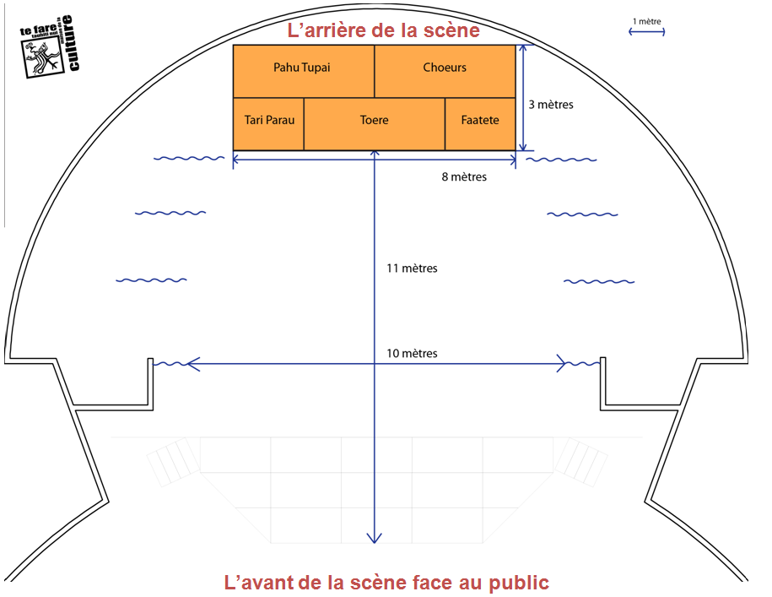
Back of stage

Front of stage – Facing the audience
Note: Musician #1 is the one on the far left (seaside), musician #6 is the one standing at the far right (mountain side) as seen from the audience.

It is preferable that string instruments be of electro-acoustic kind (can be wired to a PA console) for better quality sound diffusion. Each musician playing an electro acoustic string instrument will provide the jack-jack cable. In addition, certain instruments are powered by batteries. These batteries must be replaced before each performance. (Before Sound-check and before the show)

The PA mixer is digital, all “Sound-check” settings of the group are stored, in order to be recalled during the evening of the show. Hence it is important that what is done during Sound-check match what is desired for the show:

- No instrument change between sound-check and the evening of the show is allowed.
- No change in the location of the instruments is allowed.

Warning: as orchestras perform live, it is strongly advised that the group provides a steward during rehearsals and the evening of the show. He will be in the control room next to the sound & light technicians in order to anticipate all effects desired.

